**Lesson 4**

**Objectives**

* Components of Database Environment
* Range of Database Applications

**Database environment**

There are following major components of typical database environment.

* CASE Tools
  + computer-aided software engineering
  + Automated tools used to design database and application programs.
* Repository
  + centralized storehouse of metadata
  + A centralized knowledge base of all data definitions, data relationships, and constraints on data.
* Database Management System (DBMS)
  + software for managing the database
* Database
  + storehouse of the data
* Application Programs
  + Computer programs that are used to create and maintain the database and provide information to users.
* User Interface
  + text and graphical displays to users
* Data Administrators
  + personnel responsible for maintaining the database
* System Developers
  + personnel responsible for designing databases and software
* End Users
  + people who use the applications and databases

The relationship between above components is given below

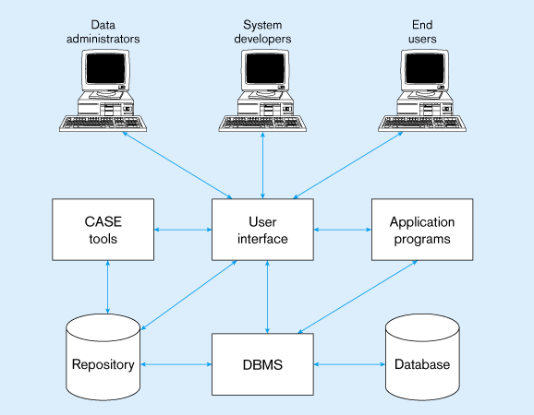

**Range of Database Applications**

Database applications can be categorized as follow in the context of usage.

* Personal Database
  + Personal databases are designed to support one user.
  + Simple form of the database
  + Some key decisions that must be considered during the development of database
    - Purchased or developed within organization
    - If it is developed within organization
      * Should it be developed by end user or
      * By professional
    - What data is required and how database should be designed
    - What commercial DBMS product should be used?
    - Who is responsible for accuracy of the data in database?
* Workgroup Database
  + Workgroup is a relatively small team of people who collaborate on the same project or application.
    - Fewer than 25 people
  + All decisions of personal database with following extra decisions
    - How database optimized?
    - How user use it at same time?
    - Which operation performed on workstation?
    - Which operation performed on server?
* Departmental/Divisional database
  + Departmental and divisional databases are designed to support the various functions and activities of a department or division.
  + It is most common type of databases.
  + Following decisions are important.
  + 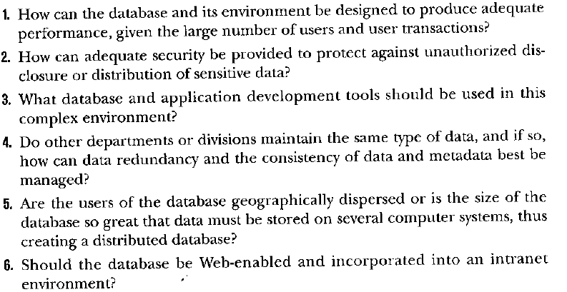
* Enterprise Database
  + An enterprise database is one whose scope is the entire organization or enterprise.
* Web Enabled database